# **Being a Team Player**

**What does it mean to be a team player?** Ask ten people, and you will most likely get ten different answers, but with some common threads.

For purposes of this tailgate talk, we will use the following definition taken from the article [What Does It Really Mean To Be a Team (in good and bad times) (lonelyentrepreneur.com)](https://lonelyentrepreneur.com/what-does-it-mean-to-be-a-team/): *A team player is someone who puts aside his personal goals and works well with others, doing what they need to do to strive for a common goal.*

## **What are the qualities of a good team player?**

Nobody is the perfect team player, but many people still possess some of those qualities. Common team-player qualities include being open-minded, sharing, and encouraging other group members. A team player will unify others by exchanging information and ideas to empower others and trust them. A good team player assists his team by using his strengths and clearly understanding his role.

## **What makes a good team player in a job environment?**

A good team player at work is highly reliable at all times and not just part-time. One can count on a good team player to get a job done, keep their word, meet the deadlines, and provide consistent quality work. They help the team stay on track with performance and organization.

## **What skills do you need to be a team player?**

Let us go through some skills that a team member must have:

* Each employee should work to be the best communicator possible to be a good team member. You should carefully put your thoughts into words for everyone to understand them well. It would help if you were sensible enough to carefully choose your words for sharing your thoughts with others. One should work towards being able to speak clearly and without confusing others.
* Be forgiving. Don’t unnecessarily drag out issues. Be the better person and step up to say you are sorry. Don’t take things to heart.
* You need to show that you can be relied upon and are trustworthy to survive in a team. Do not ever discuss any issues with someone outside the team. Know how to draw a line between your personal and professional lives. The team's strategies, agendas, and critical issues should not be discussed with anyone except those involved. Any information that is personal or confidential must not be leaked. A team member might trust you and share something meaningful and personal with you, don’t reveal their secret in front of others. It will hurt them.
* You must be a good listener to be an effective team player. Listen to other people as well. Don’t draw conclusions on your own. Sit with your team and get their ideas on new policies or ways of doing work before implementing. Give a patient ear to your team members before coming to any decision. Participate in active listening. This involves concentrating on what someone is saying and confirming that you understand them correctly.
* A team player always puts the team’s needs first, and everything else should take a back seat. Do not always think about your interests.
* Having a positive attitude is a must for all team members. Do not spread negativity around. Avoid blame games and spreading unnecessary rumors. Sometimes it’s best to ignore things that are not that important rather than fight over them. Please don’t go by what others say; it is always better to follow your instinct. One should never use derogatory sentences or inappropriate remarks against anyone in the team. Try to look at the positives in any situation rather than the negatives.
* Each team member should practice personal accountability. This means each team member is willing to be responsible for their actions, whether positive or negative. To be a team player, you must be willing to take ownership of your mistakes. Being accountable can help build trust with your teammates and earn their respect. Acknowledging you don’t know everything can be an opening for valuable feedback from your team.
* 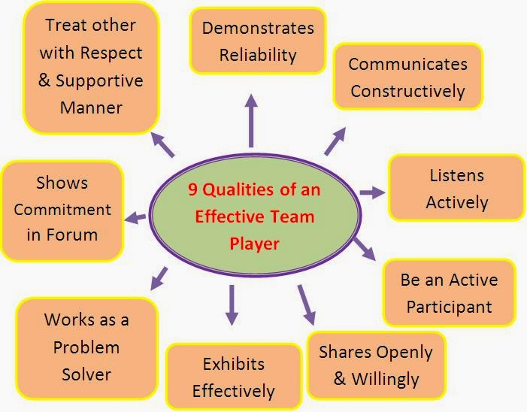Team players must be flexible to accommodate the needs and schedules of their teammates. Flexibility is essential because it allows different people working on a project to communicate regularly and share responsibilities.

Image courtesy of blogspot.com

* Team players should share a joint commitment for the team’s good. Showing commitment to your team is an integral part of being a team player. Team players are not discouraged by challenges, and they commit to solving any problems they encounter. They should have a genuine interest in each team members’ motivations and goals and regularly ask how they can help others.
* Team members should feel comfortable expressing their views in front of others. Do not sit quietly in meetings. Don’t assume that others will laugh at you or make fun of your ideas.
* Effective team players are also effective problem solvers. Share your positive energy with your team to boost mood and morale. At the same time, they are open to feedback and exploring alternatives to accomplishing team tasks.
* Outstanding team players set an example for others on the team to follow. They are a little more focused and concentrated on their work rather than interfering in others’ work. They respectfully ask others if they need help from time to time if they see others struggling. They are willing to help others when requested without hesitation.
* Team players work on building solid relationships with their teammates. By following the tips in this Tailgate Talk, you will be well on your way to being a team player that others will respect and follow.